**BDBP106: Linux and Python programming LAB 3**

1. (1) What does each of the following commands do? Print the output and attach it as part

of your Lab3 document

cd refers to the change directory

(a) cd / : takes to the root directory

(b) cd ~: takes to the home directory

(c) cd: takes to the home directory

(d) cd ..: takes to one level up directory

(e) cd .: keeps us in the current directory

(f) cd -: takes us to the previous working directory

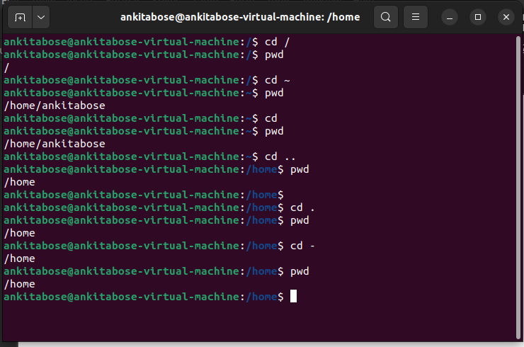

2. When using the ls command, what is the difference between -R option and -r option?

Demonstrate the difference by typing the appropriate commands and printing the output

to your Lab3 document.

Ls -R lists all the files along with the directories

ls -r lists all the files along with the directories in reverse order with respect to the ls -R command output

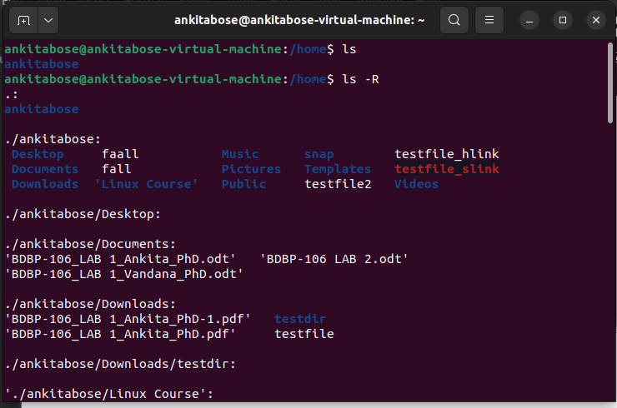

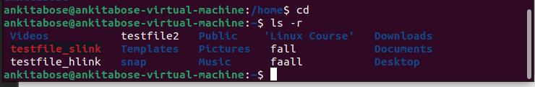

3. How do I find out what directory I am currently in?

The directory that I am currently in can be found out by the command “pwd” which is “present working directory.

4. How do I list files sorted by modification time, but with oldest first? Find the correct combination of options to do this task. Print the output of your command with appropriate screenshots to demonstrate this in your Lab3 document.

- The command “ls -ltr” does the task

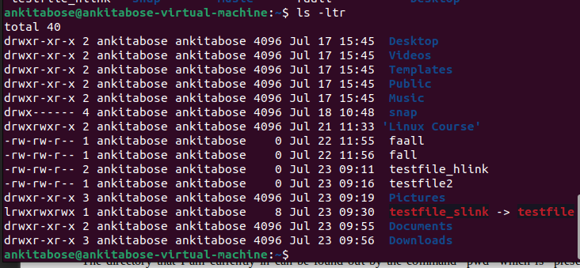

5. What is the difference between (explain in your own words) ls -ltr and ls -l? Demon-

strate the difference with appropriate screenshot and explanations.

ls -ltr lists the files along with the modification time in an organised manner, say the older first and the newest last where as the ls -l lists files in an unsorted way



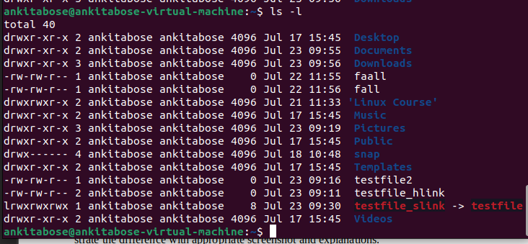

6. What is the difference between ls -alF, ls -A and ls -CF. Demonstrate the differences

with appropriate examples as screenshot and explanations.

-a shows all the files including the hidden files, -l gives a long listing format in s detailed way and -F add indicators to the file names whereas in ls -A doesnt show the parent and current directory

ls -CF doesnt show any hidden files as well as it omits the parent and current directory from the list

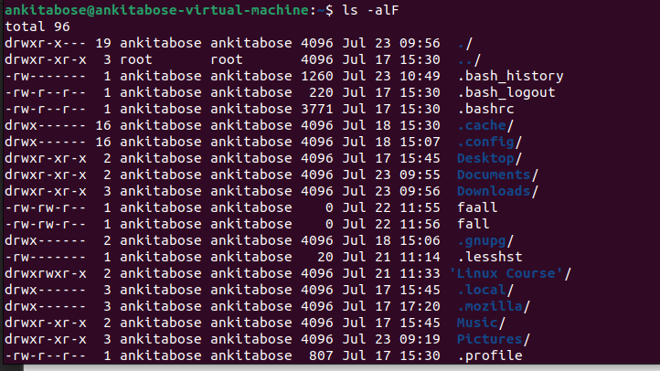

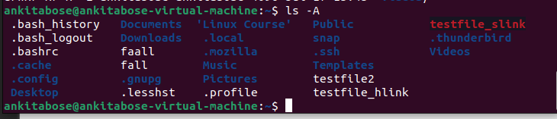

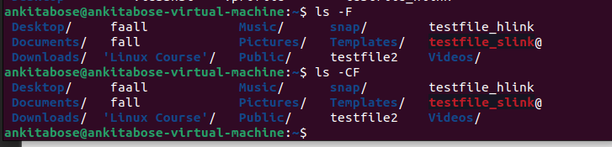

7. Describe how you would use a combination of color codes in the command prompt

appearance. Demonstrate this using an example where you managed to combine the

colors blue and green?

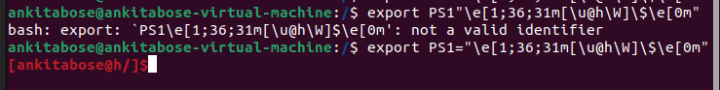

8. Find the option of ls that lists the contents of a directory in the long format, but

without the primary group information. (Note: ls -l lists files in the long format with

the primary group information)

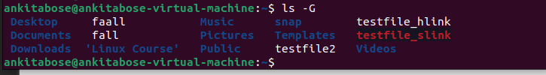

9. Download the etc.zip folder sent to you by email, unzip it and rename it as etc_learn.

Change your directory to etc_learn. In this directory do the following using the neces-

sary wildcards:

(a) list the files or directories starting with b

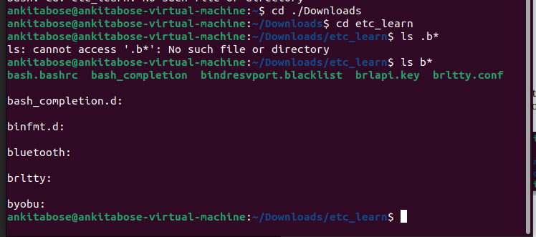

(b) list the files or directories starting with any of the letters from a-k

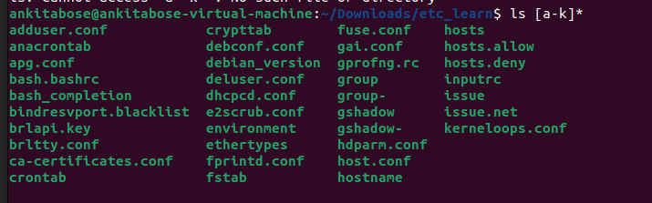

(c) list files or directories ending with d

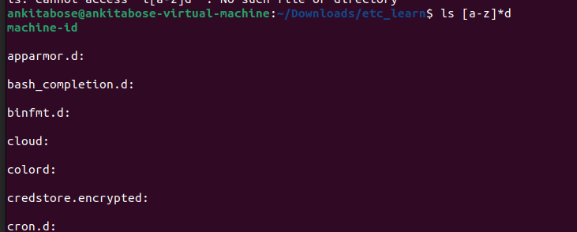

(d) list the files or directories containing the pattern with conf. How many are there?

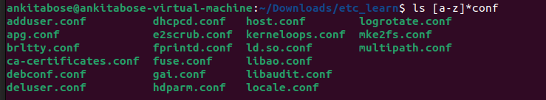

(e) Output the last three lines of the file /etc/resolve.conf

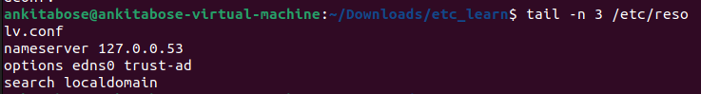

(f) list files that begin with g or l

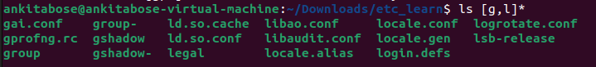

10. Create the following directories: /home/ibab/lab3/Q10/q1 and /home/ibab/lab3/Q10/q2

using one command. Attach a screenshot of the commands and the outputs of this and

below exercises in your document.

(i) Enter the q1 directory using one command

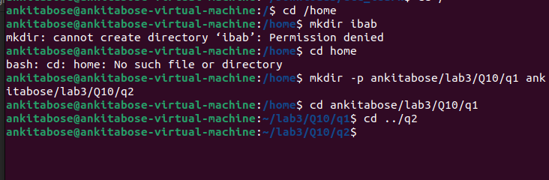(ii) Change directories from q1 to q2 using one command

(iii) copy the q1 directory to q1_copy

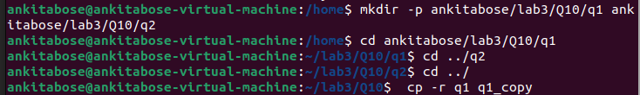

(iv) delete the q1_copy interactively

